**Challenges:**

Q.1 Write a program to find maximum occurring character from given string.

Q.2 Write a program to print duplicate characters with number of occurrence in given string.

Q.3 Write a program to reverse the words of given string.

Q.4

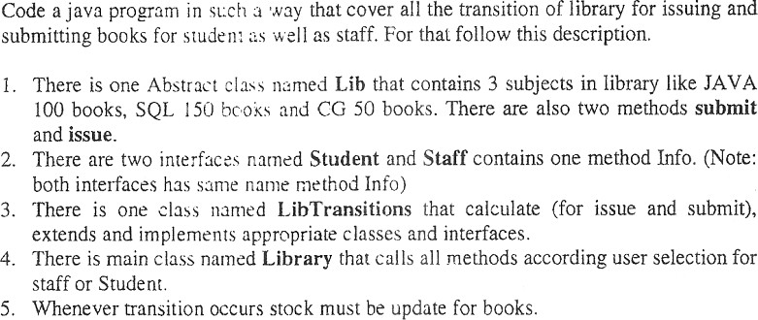

Q.5 Write a program that will define a superclass Shape that defines dim1 and dim2 and a method Area() for 2 dimensional shapes. Define rectangle, circle and triangle subclasses with overridden method Area() to calculate area of itself.

Q.6 Define a class series with overloaded methods to print Fibonacci series. This class must contain the following type of method:

1. void fibo() : It will print 10 terms of series
2. void fibo(int terms): It will print total N terms specified by terms parameter.

void fibo(int start, int end) : It will print all the terms between starting and ending numbers.

Q.7 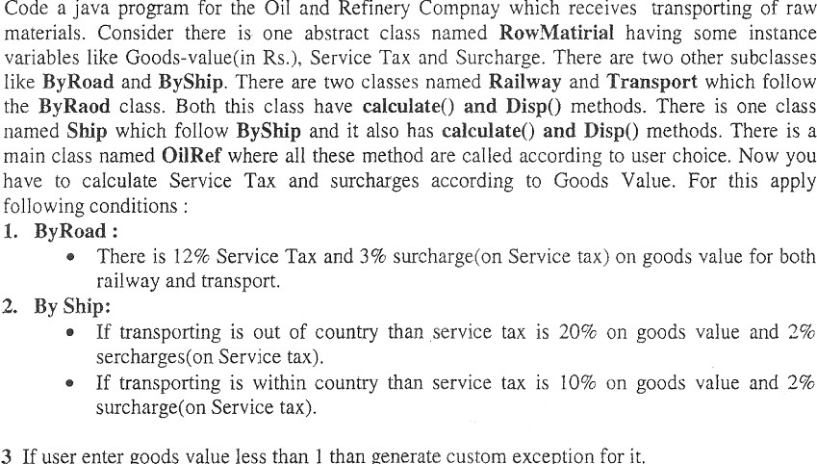

Custom Exceprion Program

package pkg24_div_iii;

class InvalidAgeException extends Throwable

{

public InvalidAgeException(String str)

{

super(str);

}

}

public class TestCustomException {

static void validate(int Age) throws InvalidAgeException

{

if(Age <18)

{

throw new InvalidAgeException("Invalid age to cast the vote");

}

else

{

System.out.println("Welcome to vote");

}

}

public static void main(String[] args) {

try

{

validate(16);

}

catch(InvalidAgeException e)

{

System.out.println("jdd"+e);

}

System.out.println("Rest of the code");

}

}

X===== X ===== X ===== X ===== X ===== X ===== X ===== X ===== X ===== X